[](https://www.google.co.uk/imgres?imgurl=http://gallery.yopriceville.com/var/albums/Free-Clipart-Pictures/Grass-Grounds-Coverings-PNG-Clipart/Grass_PNG_Picture_Clipat.png?m=1399681007&imgrefurl=http://gallery.yopriceville.com/Free-Clipart-Pictures/Grass-Grounds-Coverings-PNG-Clipart/Grass_PNG_Picture_Clipat&docid=ousYfanC4CHydM&tbnid=oRSOsiD04DLuYM&w=3600&h=550&ei=TUmhVJjkI4HcUtqdgvAK&ved=0CAYQxiAwBA&iact=c)

**Saturday 2nd July**

Under 7 mixed/boys

Under 9 mixed/boys

Under 11 mixed/boys

**Sunday 3rd July**

Under 8 mixed/boys

Under 10 mixed/boys

Under 12 mixed/boys

***Summer 6ixes***

**Summer 6-a-side tournament 2016**

**Saturday 2nd/Sunday 3rd July**

**Holbeach Community Sports Academy PE12 7QJ**

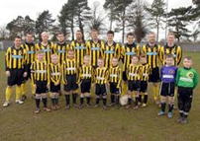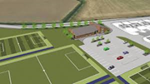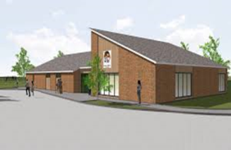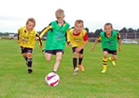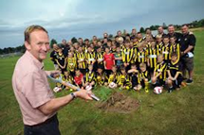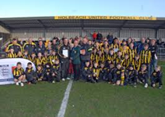

* **Cost per team £25.00 (non-refundable)**
* **Squads to comprise of 6 players and up to 4 subs per team**
* **Guaranteed 5 games ( if full quota of teams achieved)**
* **Registration between 09.00 – 09.30, games commence 10.00am**
* **Trophies and medals presented to winners and runners up (age appropriate)**

**For further details, or to book your place in the Summer 6ixes tournament, please contact Neal Collishaw (Tournament Organiser) on 07711 561 891 email** [**hucsa.tournament@btinternet.com**](mailto:hucsa.tournament@btinternet.com) **details can also be found on our website www.holbeachunitedcsa.org.uk**